ADAPTAÇÃO DAS CHAVES DE BUSCA
EXEMPLO TEMA ANTIFÚNGICOS

PUBMED

PASSO A PASSO
1) Utilizar as estratégias de busca conforme disponibilizado no arquivo da BU (revisado por Gilberto/Rodrigo)
2) Checar se todos os termos MeSH terms estão corretos (inclusive vírgulas): https://www.ncbi.nlm.nih.gov/mesh
3) Combinar chaves: (odontologia) AND (tema da revisão) AND (clinical trials)
4) Adicionar filtro para ano (2015-2025)

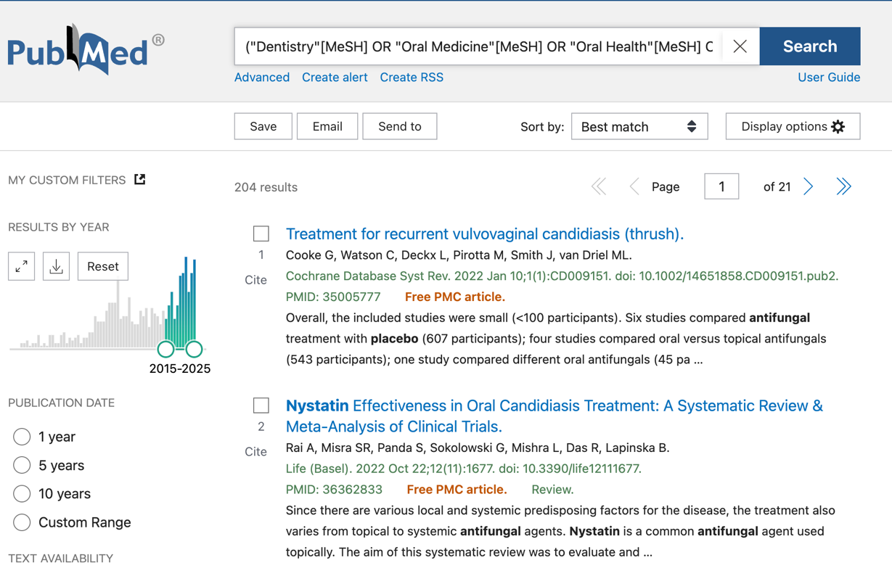

ESTRUTURA
("descritor"[MeSH] OR "termo livre 1" OR "termo livre 2")

CHAVE
("Dentistry"[MeSH] OR "Oral Medicine"[MeSH] OR "Oral Health"[MeSH] OR "Dental Care"[MeSH] OR "Stomatognathic Diseases"[MeSH] OR "Toothache/drug therapy"[MeSH] OR "Surgery, Oral"[MeSH Terms] OR "Endodontics"[MeSH] OR "Periodontics"[MeSH] OR "dentistry" OR "oral medicine" OR "oral health" OR "stomatology" OR "stomatognathic" OR "odontology" OR "toothache" OR "dental pain" OR "oral pain" OR "orofacial pain" OR "temporomandibular" OR "TMJ" OR "TMD" OR "oral surgery" OR "maxillofacial" OR "maxillo-facial" OR "jaw" OR "jaws" OR "maxilla" OR "maxillary" OR "mandible" OR "mandibular" OR "endodontic" OR "endodontics" OR "dental root" OR "root canal" OR "periodontic" OR "periodontics" OR "periodontal" OR "periodontium" OR "prosthodontic" OR "prosthodontics" OR "orthodontic" OR "orthodontics" OR "pedodontic" OR "pedodontics" OR "pediatric dentistry" OR "paediatric dentistry" OR "tooth extraction" OR "teeth extraction" OR "dental extraction" OR "oral infection" OR "dental infection" OR "buccal infection")
AND
("Antifungal Agents"[MeSH] OR "Drug resistance, Fungal"[MeSH] OR "antifungal" OR "anti-fungal" OR "antimycotic" OR "fungicide" OR "fungistatic" OR "fluconazole" OR "itraconazole" OR "ketoconazole" OR "miconazole" OR "clotrimazole" OR "nystatin" OR "amphotericin" OR "voriconazole" OR "posaconazole" OR "terbinafine" OR "griseofulvin" OR "caspofungin" OR "micafungin" OR "anidulafungin" OR "polyene" OR "azole" OR "triazole" OR "imidazole")
AND
("Clinical Trial"[Publication Type] OR "clinical trial" OR "randomized trial" OR "randomized trial" OR "controlled trial" OR "non-randomized trial" OR "non-randomised trial" OR "parallel trial" OR "cross-over trial" OR "crossover trial" OR "superiority trial" OR "non-inferiority trial" OR "equivalence trial" OR "matched-pair trial" OR "two-arm trial" OR "three-arm trial" OR "drug trial" OR "quasi-experimental" OR "clinical study" OR "clinical research" OR "interventional study" OR "placebo" OR "RCT")

EMBASE

PASSO A PASSO
1) Substituir aspas duplas por aspas simples
2) Tudo que for [MeSH] ou [MeSH Terms] substituir por /exp para usar o Emtree correspondente
3) Dentro da mesma chave, agrupar descritores e termos livres: (("descritores") OR ("termo livres"))
4) Usar o delimitador :ti,ab,kw apenas no grupo de termos livres
5) Adicionar filtro para ano (2015-2025), fonte (Embase) e tipo de publicação (Articles/Articles in press)
6) Colar chave no recurso Advanced

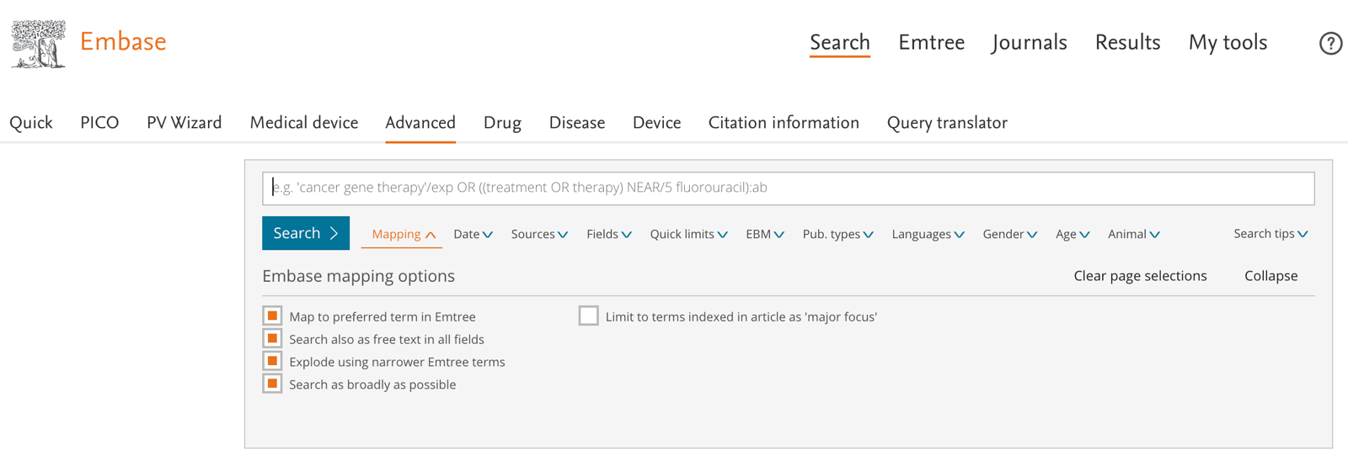

ESTRUTURA
(("descritor"/exp) OR ('termo livre 1' OR 'termo livre 2'):ti,ab,kw)

CHAVE
(('Dentistry'/exp OR 'Oral Medicine'/exp OR 'Oral Health'/exp OR 'Dental Care'/exp OR 'Stomatognathic Diseases'/exp OR 'Toothache/drug therapy'/exp OR 'Surgery, Oral'/exp OR 'Endodontics'/exp OR 'Periodontics'/exp) OR ('dentistry' OR 'oral medicine' OR 'oral health' OR 'stomatology' OR 'stomatognathic' OR 'odontology' OR 'toothache' OR 'dental pain' OR 'oral pain' OR 'orofacial pain' OR 'temporomandibular' OR 'TMJ' OR 'TMD' OR 'oral surgery' OR 'maxillofacial' OR 'maxillo-facial' OR 'jaw' OR 'jaws' OR 'maxilla' OR 'maxillary' OR 'mandible' OR 'mandibular' OR 'endodontic' OR 'endodontics' OR 'dental root' OR 'root canal' OR 'periodontic' OR 'periodontics' OR 'periodontal' OR 'periodontium' OR 'prosthodontic' OR 'prosthodontics' OR 'orthodontic' OR 'orthodontics' OR 'pedodontic' OR 'pedodontics' OR 'pediatric dentistry' OR 'paediatric dentistry' OR 'tooth extraction' OR 'teeth extraction' OR 'dental extraction' OR 'oral infection' OR 'dental infection' OR 'buccal infection'):ti,ab,kw)
AND
(('Antifungal Agents'/exp OR 'Drug resistance, Fungal'/exp) OR (antifungal OR 'anti-fungal' OR antimycotic OR fungicide OR fungistatic OR fluconazole OR itraconazole OR ketoconazole OR miconazole OR clotrimazole OR nystatin OR amphotericin OR voriconazole OR posaconazole OR terbinafine OR griseofulvin OR caspofungin OR micafungin OR anidulafungin OR polyene OR azole OR triazole OR imidazole):ti,ab,kw)
AND
(('clinical trial'/exp) OR ('randomized trial' OR 'randomized trial' OR 'controlled trial' OR 'non-randomized trial' OR 'non-randomised trial' OR 'parallel trial' OR 'cross-over trial' OR 'crossover trial' OR 'superiority trial' OR 'non-inferiority trial' OR 'equivalence trial' OR 'matched-pair trial' OR 'two-arm trial' OR 'three-arm trial' OR 'drug trial' OR 'quasi-experimental' OR 'clinical study' OR 'clinical research' OR 'interventional study' OR 'placebo' OR 'RCT'):ti,ab,kw)
AND
[2015-2025]/py AND [embase]/lim AND ('article'/it OR 'article in press'/it)

SCOPUS

PASSO A PASSO
1) Remover todos os [MeSH] e [MeSH Terms] – Scopus não possui vocabulários controlados
2) Adicionar delimitador TITLE-ABS-KEY no início das chaves
3) Adicionar filtros para ano (2015-2025) e tipo de publicação (artigos)
4) Colar chaves no recurso Advanced Search

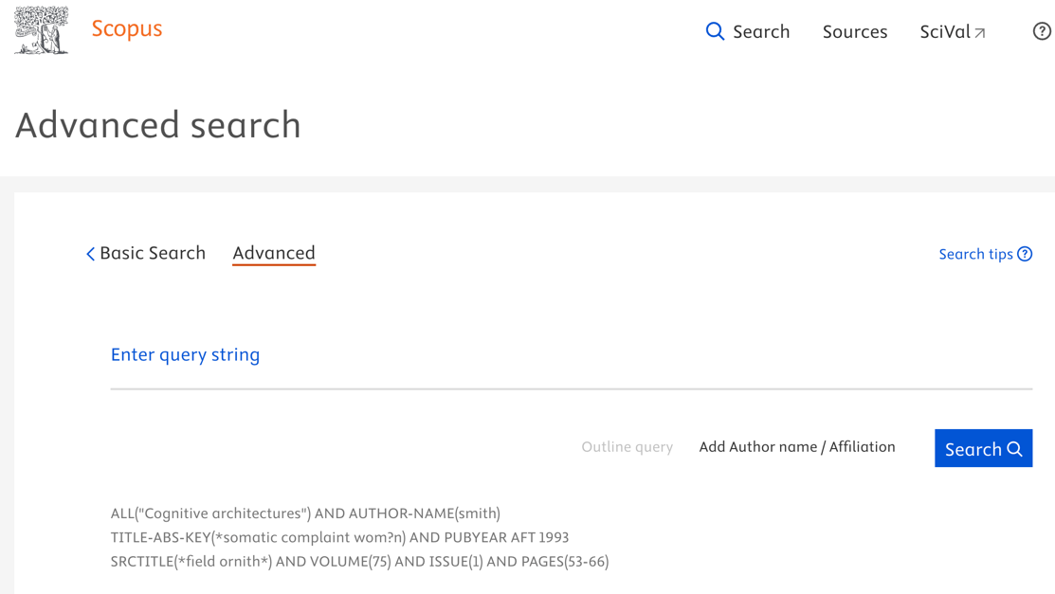

ESTRUTURA
TITLE-ABS-KEY("termo livre 1" OR "termo livre 2")

CHAVE
TITLE-ABS-KEY("dentistry" OR "oral medicine" OR "oral health" OR "stomatology" OR "stomatognathic" OR "odontology" OR "toothache" OR "dental pain" OR "oral pain" OR "orofacial pain" OR "temporomandibular" OR "TMJ" OR "TMD" OR "oral surgery" OR "maxillofacial" OR "maxillo-facial" OR "jaw" OR "jaws" OR "maxilla" OR "maxillary" OR "mandible" OR "mandibular" OR "endodontic" OR "endodontics" OR "dental root" OR "root canal" OR "periodontic" OR "periodontics" OR "periodontal" OR "periodontium" OR "prosthodontic" OR "prosthodontics" OR "orthodontic" OR "orthodontics" OR "pedodontic" OR "pedodontics" OR "pediatric dentistry" OR "paediatric dentistry" OR "tooth extraction" OR "teeth extraction" OR "dental extraction" OR "oral infection" OR "dental infection" OR "buccal infection")
AND
TITLE-ABS-KEY("antifungal" OR "anti-fungal" OR "antimycotic" OR "fungicide" OR "fungistatic" OR "fluconazole" OR "itraconazole" OR "ketoconazole" OR "miconazole" OR "clotrimazole" OR "nystatin" OR "amphotericin" OR "voriconazole" OR "posaconazole" OR "terbinafine" OR "griseofulvin" OR "caspofungin" OR "micafungin" OR "anidulafungin" OR "polyene" OR "azole" OR "triazole" OR "imidazole")
AND
TITLE-ABS-KEY("clinical trial" OR "randomized trial" OR "randomized trial" OR "controlled trial" OR "non-randomized trial" OR "non-randomised trial" OR "parallel trial" OR "cross-over trial" OR "crossover trial" OR "superiority trial" OR "non-inferiority trial" OR "equivalence trial" OR "matched-pair trial" OR "two-arm trial" OR "three-arm trial" OR "drug trial" OR "quasi-experimental" OR "clinical study" OR "clinical research" OR "interventional study" OR "placebo" OR "RCT")
AND
(PUBYEAR > 2014 AND PUBYEAR < 2026) AND (LIMIT-TO (DOCTYPE, "ar")

WEB OF SCIENCE

PASSO A PASSO
1) Remover todos os [MeSH] e [MeSH Terms] – Web of Science não possui vocabulários controlados
2) Usar o delimitador TS= antes de cada chave
3) Colar chaves no recurso "QUERY BUILDER", não no "FIELDED SEARCH"
4) Usar filtros de ano (2015-2025) e tipo de publicação (Articles) – no site, não inserir dentro da chave

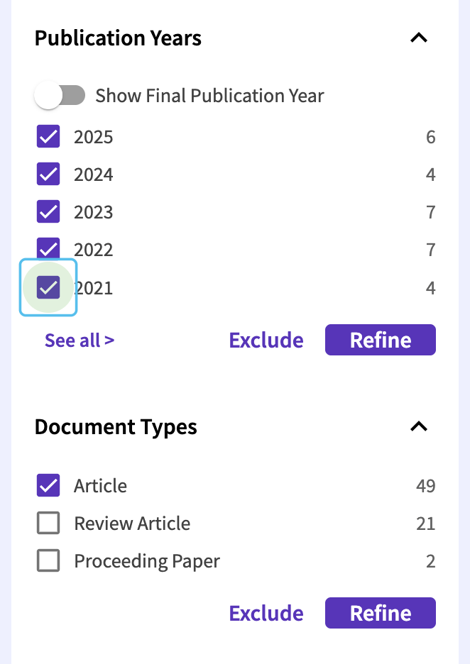
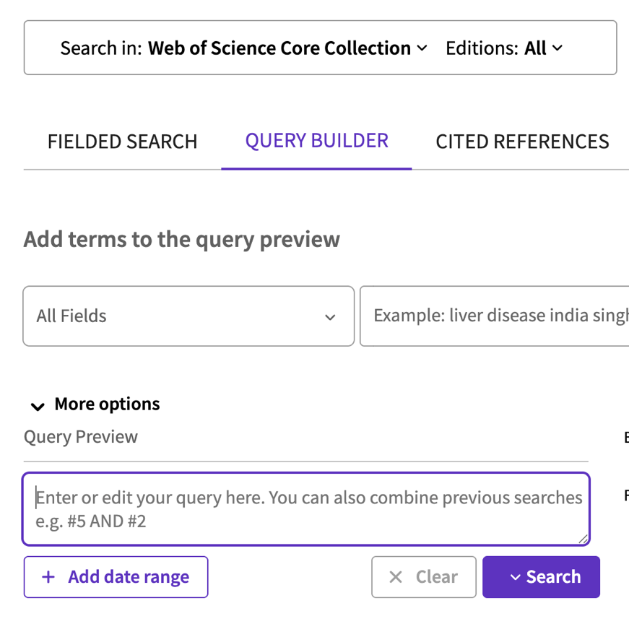

ESTRUTURA
TS=("termo livre 1" OR "termo livre 2")

CHAVE
TS=("dentistry" OR "oral medicine" OR "oral health" OR "stomatology" OR "stomatognathic" OR "odontology" OR "toothache" OR "dental pain" OR "oral pain" OR "orofacial pain" OR "temporomandibular" OR "TMJ" OR "TMD" OR "oral surgery" OR "maxillofacial" OR "maxillo-facial" OR "jaw" OR "jaws" OR "maxilla" OR "maxillary" OR "mandible" OR "mandibular" OR "endodontic" OR "endodontics" OR "dental root" OR "root canal" OR "periodontic" OR "periodontics" OR "periodontal" OR "periodontium" OR "prosthodontic" OR "prosthodontics" OR "orthodontic" OR "orthodontics" OR "pedodontic" OR "pedodontics" OR "pediatric dentistry" OR "paediatric dentistry" OR "tooth extraction" OR "teeth extraction" OR "dental extraction" OR "oral infection" OR "dental infection" OR "buccal infection")
AND
TS=("antifungal" OR "anti-fungal" OR "antimycotic" OR "fungicide" OR "fungistatic" OR "fluconazole" OR "itraconazole" OR "ketoconazole" OR "miconazole" OR "clotrimazole" OR "nystatin" OR "amphotericin" OR "voriconazole" OR "posaconazole" OR "terbinafine" OR "griseofulvin" OR "caspofungin" OR "micafungin" OR "anidulafungin" OR "polyene" OR "azole" OR "triazole" OR "imidazole")
AND
TS=("clinical trial" OR "randomized trial" OR "randomized trial" OR "controlled trial" OR "non-randomized trial" OR "non-randomised trial" OR "parallel trial" OR "cross-over trial" OR "crossover trial" OR "superiority trial" OR "non-inferiority trial" OR "equivalence trial" OR "matched-pair trial" OR "two-arm trial" OR "three-arm trial" OR "drug trial" OR "quasi-experimental" OR "clinical study" OR "clinical research" OR "interventional study" OR "placebo" OR "RCT")

